WR-00906-02-A

Rev. 1/25

How to Fill Out Your Observing Form… New!
 | Please write the last two digits of the year and the two digits of the month (example: 2025 = 25) and (example: April=04) Also the time that you observe each day (example: 7 am). Note: If you report at 7am, the precipitation total is from the past 24-hours… No date shifting! |  | Please enter your county number (see the list below for numbers). Also enter your township, range and section number. These numbers can be found on county plat books. |  | This is the network  number. “7” is the SWCD network.
Use your phone camera on the QR code above to go to our website : https://climateapps.dnr  .state.mn.us/update/ | 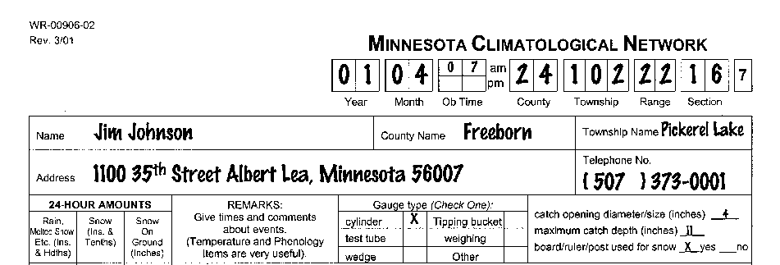 |  |  |  | Please print the name of your Township
Be sure to include your name, street address and zip code. |  |  |  |  | Please enter your phone number
Thank you for being a rain gage reader! | For information on how to fill out rain and snow, please see “How to Record Rain and Snow” below. |  | Please enter your gauge type, other information about your rain gauge, and if you have a snowboard. |  | and email.
How to Record and Report Rain and Snow  SUMMER:  Left Column - Rain Gauge: Rainfall measurements should be entered to the nearest hundredth of an inch. (Example: .07 or 1.32.) in the left column only. Record the rainfall for the day on which the observation was made. Any rainfall after the observation time (which should be the same time every day) will be measured on the next day. Enter T or trace for amounts less than .01 (one hundredth) of an inch. If no rain has fallen enter zero (0).  WINTER:  Left Column - Melted Snow - Outer Tube: During the winter, use only the outer tube of the gauge to collect snow. At observation time melt the collected snow and measure the water obtained to the nearest hundredth of an inch (Example: .14) using the graduated center tube. Enter the measurement in the left column.  Middle Column – Snowfall - Yardstick: Measure new snowfall (fallen during the last 24 hours) to the nearest tenth of an inch (Example 2.4 or .5) using a yardstick. Select a previously bare area, such as a driveway and take the average of several measurements. A snowboard may be useful. Record this amount in the center column only.  Right Column – Depth of Snow on Ground - Yardstick: Measure the depth of snow on the ground to the nearest inch using a yardstick. Repeat this measurement at several spots where there was no drifting and take the average of the readings of the snow depth. Record this amount in the right column only. |  | COUNTY NUMBERS  1 AITKIN  2 ANOKA  3 BECKER  4 BELTRAMI  5 BENTON  6 BIG STONE  7 BLUE EARTH  8 BROWN  9 CARLTON  10 CARVER  11 CASS  12 CHIPPEWA  13 CHISAGO  14 CLAY  15 CLEARWATER  16 COOK  17 COTTONWOOD  18 CROW WING  19 DAKOTA  20 DODGE  21 DOUGLAS  22 FARIBAULT  23 FILLMORE  24 FREEBORN  25 GOODHUE  26 GRANT  27 HENNEPIN  28 HOUSTON  29 HUBBARD  30 ISANTI  31 ITASCA  32 JACKSON  33 KANABEC  34 KANDIYOHI  35 KITTSON  36 KOOCHICHING  37 LAC QUI PARLE  38 LAKE  39 LAKE OF THE WOODS  40 LE SUEUR  41 LINCOLN  42 LYON  43 MCLEOD |  | 44 MAHNOMEN  45 MARSHALL  46 MARTIN  47 MEEKER  48 MILLE LACS  49 MORRISON  50 MOWER  51 MURRAY  52 NICOLLET  53 NOBLES  54 NORMAN  55 OLMSTED  56 OTTER TAIL  57 PENNINGTON  58 PINE  59 PIPESTONE  60 POLK  61 POPE  62 RAMSEY  63 RED LAKE  64 REDWOOD  65 RENVILLE  66 RICE  67 ROCK  68 ROSEAU  69 SAINT LOUIS  70 SCOTT  71 SHERBURN  72 SIBLEY  73 STEARNS  74 STEELE  75 STEVENS  76 SWIFT  77 TODD  78 TRAVERSE  79 WABASHA  80 WADENA  81 WASECA  82 WASHINGTON  83 WATONWAN  84 WILKIN  85 WINONA  86 WRIGHT  87 YELLOW MEDICINE

Observing Notes
Please include all rain (or liquid equivalent of snow) in the left hand column. Snowfall is in the middle column. Snow depth is in the right column.  “X” means no reading. The gauge was not out on these days.  Cumulative Total: Means gauge was in place from 10th to the 13th but was not read till the 13th. (This reading is the total from the 10th –13th.)  Note! Even though it rained in the afternoon and evening of the 19th, the total is reported on the 20th.  For no precipitation use a ‘0’ for zero.  A “T” for a Trace of precipitation.  Place an “X” in the last box if there is an X for any of the days that month. | 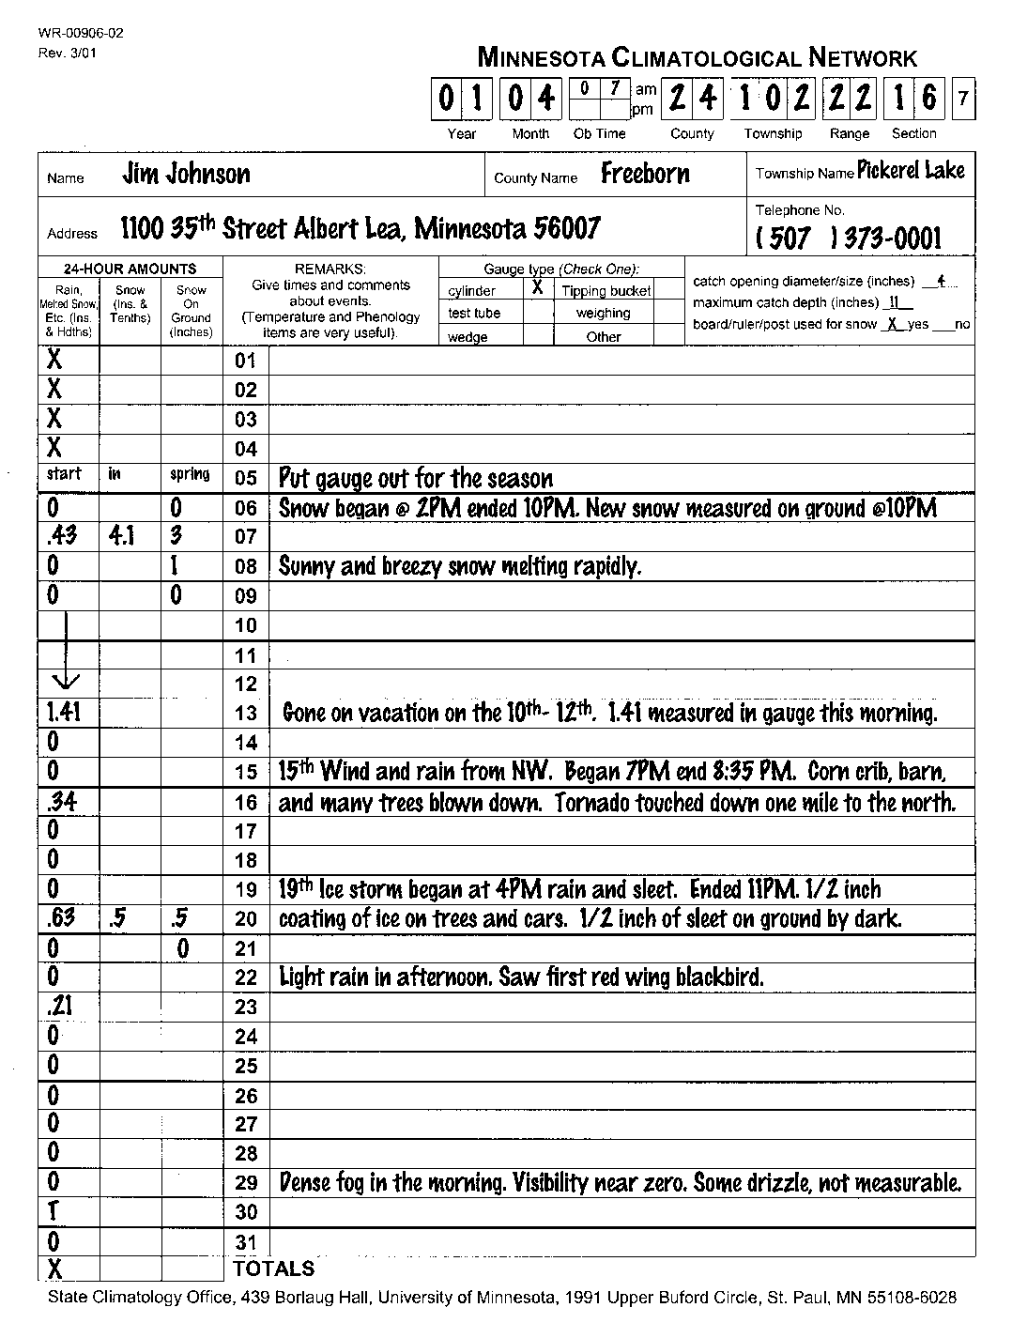
Please check your address for the State Climatology Office.  State Climatology Office  439 Borlaug Hall  1991 Upper Buford Circle  St. Paul, MN 55108-6028 | Draw an “X” on each day for which the gauge was not in use for whatever reason was not collecting precipitation. Note the days on which you put out or took in your gauge.  Draw a vertical line through days on which you did not observe but the gauge was collecting. (If you know the days were dry but simply did not check your gauge, use zeros instead.)  On days with zero precipitation, a simple ‘0’ is preferred over a blank or ‘0.00’.  The State Climatology Office data will interpret blanks as zeroes unless they have strong reasons to suspect that something else is happening. The vertical line through days with no observations is particularly important!  For snowfall observations, take care to write your values in the middle column labeled ‘SNOW (Ins.& Tenths)’. The first column, labeled ‘RAIN, MELTED SNOW, ETC (INS.&HDTHS)’ is reserved for liquid precipitation or the water equivalent of snowfall; in other words, the amount of water in the snowfall. Finally, ‘SNOW ON GROUND (INCHES)’ is for measurements of the accumulated snow pack or snow lying as affected by the total fall and the settling of snow to date.

